“Centralized Well Water Analysis And Monitoring system”

Deshmukh Monali Vijay (Author)
Dept. name of organization-Electronics and telecommunication
Name of organization - PREC LONI City,
Name of Guide: V. A. Aher
mdeshmukh1992@gmail.com

Abstract— Our project is the solution on the recent problem that occurring in the villages of India. The problem is drought. In India government had announced the condition of drought in many villages. The condition of drought is determined by identifying the certain level of water in wells. This all process is done by the officers allotted by government but as we know that India is most corrupted country .
For the help of the people in such villages government gives some financial funds. Now the condition is that if in reality there are 50 wells draught. This corrupted officers gives wrong information that there 100 wells draught so, government gives fund for 100 wells but as actually there 50 wells fund is utilized only for 50 wells. The remaining fund goes in officer’s pocket.
Here we can see, in between miss arrangement of government & officers, the loss are of only of villagers. They neither get water nor funds. So to avoid this we built up a new idea that if we develop a system that detects the actual water level of draught and gives alarm direct to the government sector; that particular area’s wells are draught then there will be ease for both government & villagers.
Introduction -
In the existing scenario, water level monitoring is of prime importance in every aspect of life. Monitoring might be of any things as like data in information world or in various sectors like, IT, computer, auditing, Government offices, various data skims etc , every field uses data so, its security plays very vital role.
If we consider the issue of an Government organization to declare draught in rural areas, villages etc, then there arises a need of using some smart system which can monitor the tanker water reach ability in rural areas .Ruling govt declares 50 litr water er man and 3 kgs of grass to every animal, but actually nothing goes in pocket of common people,,,i.e corruption… In present situation,
Petrol Allowances, TA, DA are given to Government officers to collect the water tanker reach table, but they rarely visits actual ‘well’ area (spots) in the village or public well and instead of they are collecting the information from Gramsevaks or Tahasils. Information collected in such way has no depth and leads to faulty identification of rehabitation and water tanker reach at public well and even water tankers at Zillah panchayat too. The tanker holder is quite smart. They may even convey wrong information to obtain Government or even manages people as easiest way of taking money out /in, its one kind of corruption, along with that affecting actually suffering area, corrupt officers are well covered with Gram sevaks and Sarpanch of village, but then No solution is provided for these kind of attempts up till now in country like India.
So here is a Small Efforts from our side
We propose the idea to connect the Well digitally to centralize it to Mantralaya using web technology for client-server architecture. Even we are connecting rf transmitter to every tanker with unique frequency and unique receiver to server at grampanchayt office…
Once Admin logs to our web site which is running at server side using asp.net web pages can easily monitor the water’s level at meter level and also can have log’s of water tanker presents at every time they come at well to pour water and can even tanker etc.
Considering all the above problems regarding information gap being smarter than thieves, we can implement a system which can deal very smartly with the above problems.
We have decided to implement a centralized system consisting of following features:-
- Once the system is installed it can be safeguarded with cemented structure inserted into well’s wall.
- Other approach is to use instantaneous switching mechanism as soon as one inserts it..
- Buzz a alarm on admin’s deck etc.
- Also we set some SMS alarming system. This will warn us for threshold level cross over for any parameters…
Its in short is smart well which works as like data watchman if admin wants to get access simply login to web site and obtain the data. Totally eliminating the middle chain and hence proper Government schemes could be applied to proper area…

Block Diagram:-
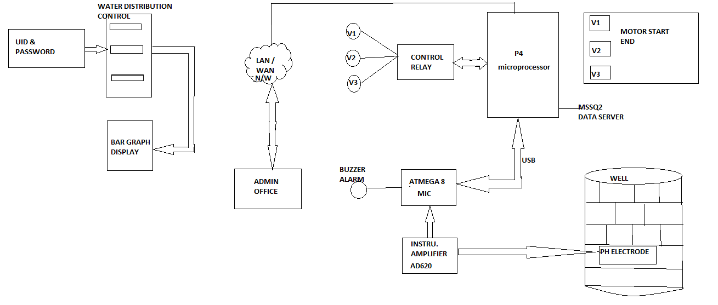
3.1 OPERATION-
The figure shows the block diagram of the Centralized well water analysis and monitoring system.There are five block such as card relay,microprocessor,motor start end controller,microcontroller,instrumation amplifier.The water distribution control room consist of user password,start and end time and bar graph display.
The security is important factor in any system. So in the water distribution system first we can create the user name and password. So the particular person log in system for water distribution. And particular time to set to start motor and stop motor.
We propose the idea to connect the Well digitally to centralize it to Mantralaya using web technology for client-server architecture. Even we are connecting RF transmitter to every tanker with unique frequency and unique receiver to server at grampanchayt office…
Once Admin logs to our web site which is running at server side using asp.net web pages can easily monitor the water’s level at meter level and also can have log’s of water tanker presents at every time they come at well to pure water and can even tanker etc.
There are three tanks v1, v2 and v3 connected to the well. The web server compare the system time and user set time.If set time is equal to the user set time then motor start and stop automatically.We can use microprocessor Pentium 4 and microcontroller ATmega8.
The microprocessor is connected through the data server ‘MSSQ2’.The main function of data server is used for water distribution.the buzzer alarm is connected to the microcontroller through digital pin. If the water is polluted in the well then bar graph color will change and buzz a alarm.
Also we set some SMS alarming system. We can develop a system buzz alarm direct connect to the admin deck by using WAN .This will warn if threshold level cross over for any parameter.In this system alarm direct to the government sector that’s particular area well are draught then there be ease for both government and villagers.
To measure the PH level ph electrode sensor are used which is placed in well by using instrumentation amplifier AD620 is as shown in figure.
So in this system we can develope the water distribution and water supply and maintaining and monitoring system.
Advantages-
1.Villagers get water and funds in timely.
2. Improve the health of people
3. Contineous recording.
4. Saving of water.
5. Reduce the peoples suffering from toxicity
of water.
6. Centralized indication.
7. Automatic distribution in timely manner.

Applications-
1. In industries.
2. In villages.
3. Water distribution and monitoring system.
4. In automation.
*References:-
1 Silliman, S.E., M. Boukari, P. Crane, F. Azonsi, and C.R. Neal, "Observations on Element Concentrations of Groundwater in Central Benin", Journal of Hydrology, vol.335(3-4), pp 374-388, 2007.
[CrossRef]
2 Petruzzi, N.M. and S.E. Silliman, "A sampling device for collection of ground water bacteria under natural gradient flow", Ground Water Monitoring and Remediation, vol.26(1), pp.85-91, Winter, 2006.
3 Thomas, Harikrishnan K., Sanil George, Paulmurugan R and Das "Studies on Water Quality of Kuttanaud Wetland Ecosystem of Kerala". R.,Poll. Res. Vol. 20(1); pp.59-66,2001.
4 Benjamin M.M., Water Chemistry, Mc Graw Hill - International Edition,New York, 2002.

